Questions with 5 answers: the first answer is the oldest most popular name, and the last answer is the current most popular names

Questions with 6 answers: the first three are within top 5 most popular name from 1966 to 2000, and the last three are within top 5 most popular name from 2000 to 2018.

I choose to ask about the most favorite name and the least favorite name and their reasons for choosing it, so I can observe characteristic of current and, maybe, future popular baby’s name.

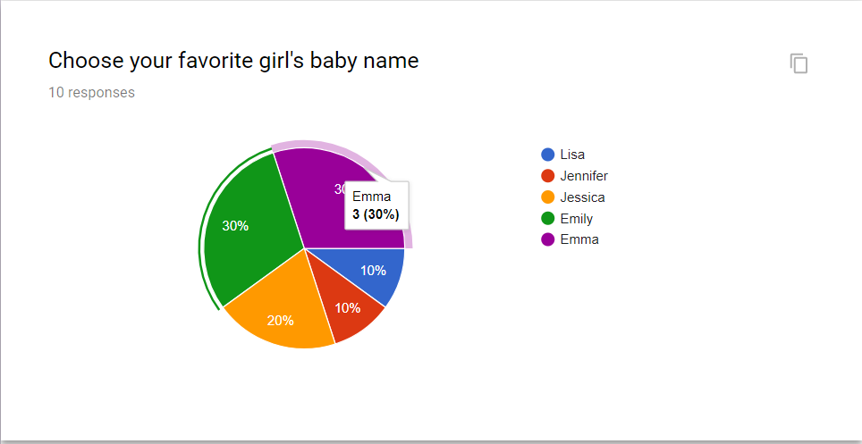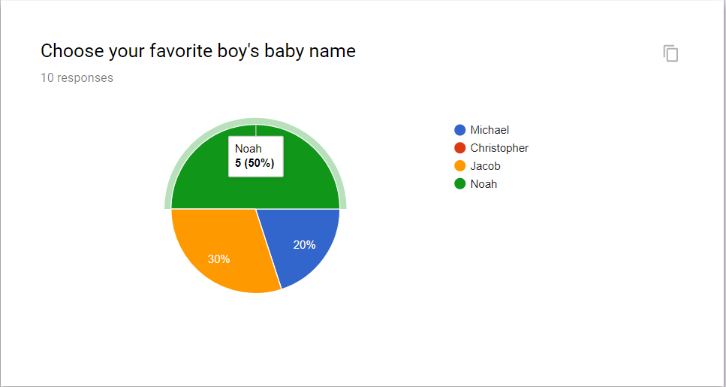 For “Choose your most favorite baby name” question, I found that the most popular baby names from more recent years are chosen in proportion to timeline where the more recent popular names are chosen more than the later popular names. According to the survey, Emily and Emma, popular name from recent years, were chosen more than Jessica, Jennifer and Lisa. (popular name from later years) The result is the same for boy’s baby name where Noah was chosen more than Jacob, Jacob was chosen more than Michael, and no one chose Christopher and Charles as their most favorite.

For “Choose your top 3 favorite name” question, according to how I structure my options for question with 6 answers, I expect people to choose options from the last three options than the first three options. According to the result, the result supports my expectation. The result from “Choose your least 3 favorite name” question is a reverse of ”Choose your top 3 favorite name” question which also support my expectation that people are less likely to like popular older name.

The pictures below are from example from “Choose your top 3 favorite name”

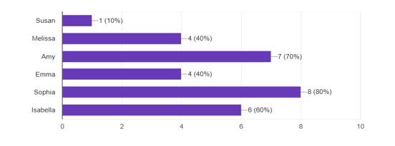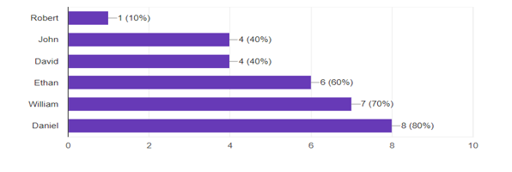

The pictures below are from example from “Choose your top 3 favorite name”

Note: Emility is a typo. It is supposed to be Emily. This is the reason why the results is off. However, according to ”the most favorite girls name,” we can still conclude that Emily should be chosen the least of all (or at least is picked less than Jessica or Jennifer which will satisfy my expectation that the weight of the first 3 names should be more than the weight of the last 3 names) because Emily is chosen as the to the most favorite girls name.

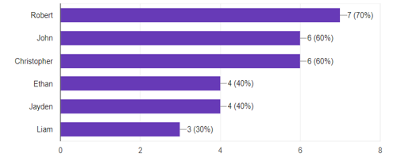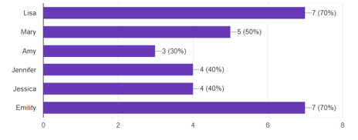

Lastly, I observed the reasons why people may like or hate the given names. The reasons why people like a name are not clear due to the limited amount of questions. “Sounds trendy” and “sound familiar”( surveys are taken by my group of friends who are around my age) support that people like more recent popular name. In contrast, ”Sound unique”(similar answer to people choosing “Too many people use these names”) was also chosen which in conflict with “Sound familiar” option. Even though, it does not support my expectation, it also does not support against my expectations that people like popular name from later year. Therefore, I can conclude that most popular name is changing as time goes on ,and is changing due to the total amount of peoples having that names.

